*SCATS Application*

Unit test results documentation

Version *1.0*

*01/20/2020*

Contents

Purpose 3

Unit Re-Test Summary 3

Unit Re-Test Details 4

AddDocumentController.java 4

ManageConsultantsController.java 5

UpdateEngagementController.java 7

ViewConsultantController.java 10

Unit Test Details (Passed Tests) 12

## Purpose

This SCATS Application Results Report provides a summary of the results of unit tests performed, the actions taken to address failed tests, and the outcome of retests performed after mitigating actions were implemented.

## Unit Re-Test Summary

The SCATS application underwent unit testing on its functional controller modules to ensure the core functionality of the module performed accurately and as expected. The testing performed assessed 11 individual controller modules, each containing various features and functions that stood to execute one primary function of the application. Of the 11 cases assessed, 4 did not pass the unit tests performed.

Interface Controllers originally tested:

* EditSystemUserController.java
* EngagementOptionsController.java
* ManageSystemUsersController.java
* NewCertificationController.java
* NewConsultantController.java
* UpdateCertificationController.java
* NewConsultantController.java

Interface Controllers addressed and re-tested as outlined in this report:

* AddDocumentController.java
* ManageConsultantsController.java
* UpdateEngagementController.java
* ViewConsultantController.java

Following the assessment, evaluation and mitigating efforts taken place after initial unit testing, all 4 initially failed test cases were effectively mitigated and passed re-tests performed as outlined in this report:

|  |  |  |  |  |
| --- | --- | --- | --- | --- |
| **Re-tested Module** | **Test Case ID** | **Pass/Fail** | **Summary of Defect** | **Mitigation Comments** |
| AddDocumentController.java | Case001 | Pass | The save date of the file is one day behind. | The sqlNewDocument function within DBManager.java was edited to pass the createdDate value to the database after incrementing the date by 1 |
| ManageConsultantsController.java | Case004 | Pass | Functionality Not Implemented | A deleteConsultant() function was written and added to the DBController.java module and mapped to all Consultant Management controllers within the code base. |
| UpdateEngagementController.java | Case009 | Pass | The end date of the Fieldwork Duration is inaccurate. | A button to initiate a manual data/view refresh were implemented on 4 separate controllers. |
| ViewConsultantController.java | Case011 | Pass | The system cannot find the image file because the filepath used within the function contains bad characters. | The Image path value within the newProfileImage() function of ViewConsultantController was changed from a toURI() value to a getAbsolutePath() value. |

# Unit Re-Test Details

## AddDocumentController.java

|  |  |  |  |  |  |
| --- | --- | --- | --- | --- | --- |
| Test Case ID | Date Tested | Pass/Fail | Severity of Defect | Summary of Defect | Comments |
| Case001 | 1/19/2020 | Fail | Minimal | The save date of the file is one day behind. | Fix: address the new document function in the Database Manager. |

**Code Analysis**: DBManager.java function sqlNewDocument contained an off-by-one error resulting in the date being committed to the database one date behind.

**Code Changes Made**: The sqlNewDocument function within DBManager.java was edited to pass the createdDate value to the database after incrementing the date by 1.

**Re-Test**:

* A new document is added to the Qualcomm engagement with a publication date of **1/10/2020**:

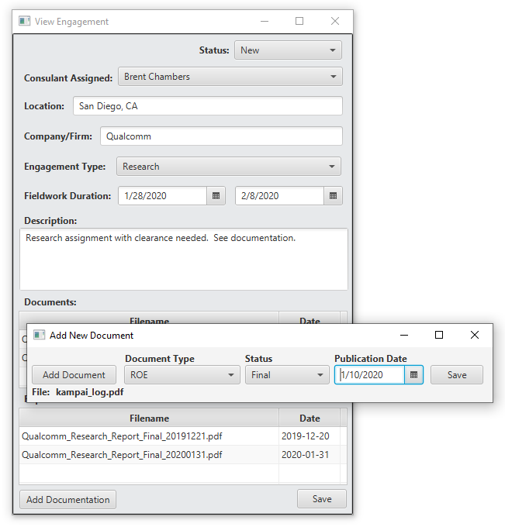

* Upon viewing the newly added document when closing and re-launching View Engagement on the Qualcomm engagement, the document’s publication date reads 1/10/2020. Status: Fixed/Pass

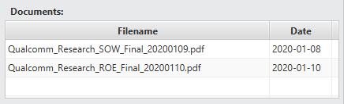

|  |  |  |
| --- | --- | --- |
| Test Case ID | Date Re-Tested | Pass/Fail |
| Case001 | 1/20/2020 | Pass |

## ManageConsultantsController.java

|  |  |  |  |  |  |
| --- | --- | --- | --- | --- | --- |
| Test Case ID | Date Tested | Pass/Fail | Severity of Defect | Summary of Defect | Comments |
| Case004 | 1/19/2020 | Fail | Medium | Functionality Not Implemented | The Delete Consultant functionality is not implemented/mapped to the menu event.  Manage Consultants can also benefit from an item count label. |

**Code Analysis**: A deleteConsultant() function was never implemented within the DBController.java module.

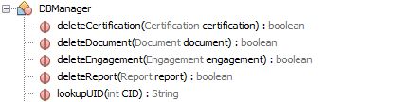

**Code Changes Made**: A deleteConsultant() function was written and added to the DBController.java module and mapped to all Consultant Management controllers within the code base.

**Re-Test**:

* Following the changes made to the DBManager module, the Consultant “John Carmack” was successfully deleted from the database using the drop-down menu functionality within the Manage Consultant tool.

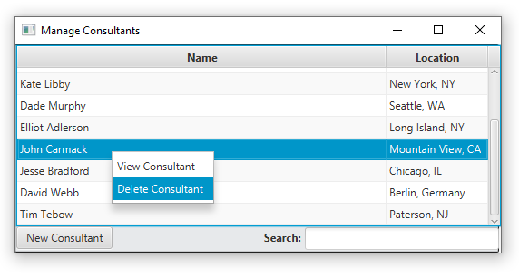

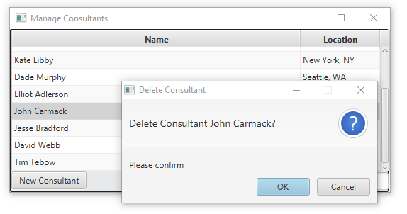

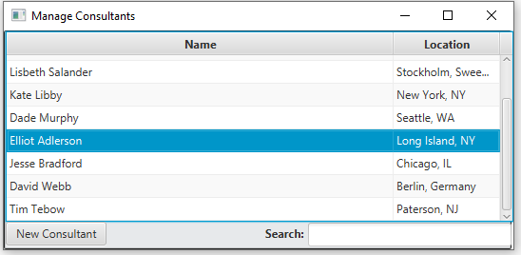

* Upon viewing the Consultant records within the SCATS backend database, it can be observed the Consultant “John Carmack” has been deleted. Status: Fixed/Pass

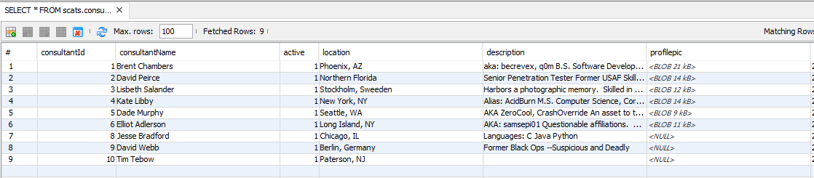

|  |  |  |
| --- | --- | --- |
| Test Case ID | Date Re-Tested | Pass/Fail |
| Case004 | 1/20/2020 | Pass |

## UpdateEngagementController.java

|  |  |  |  |  |  |
| --- | --- | --- | --- | --- | --- |
| Test Case ID | Date Tested | Pass/Fail | Severity of Defect | Summary of Defect | Comments |
| Case009 | 1/19/2020 | FAIL | Minimal | The end date of the Fieldwork Duration is inaccurate. | Fix: address the UpdateEngagement function in the Database Manager. |

**Code Analysis**: When UpdateEngagementController saves the Fieldwork End Date, the changes are made accurately. However, the changes aren’t immediately observable because the forms from which the View Engagement tool were spawned aren’t refreshed automatically.

**Code Changes Made**: A button to initiate a manual data/view refresh were implemented on:

* MainController.java

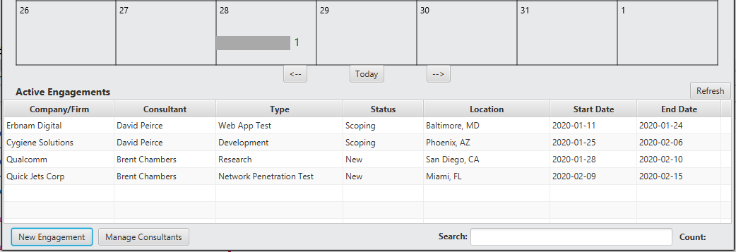

* EngagementOptionsController.java

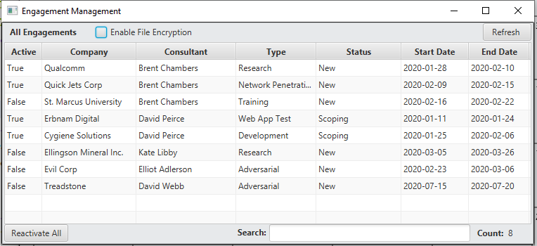

* PopupEngagementsController.java

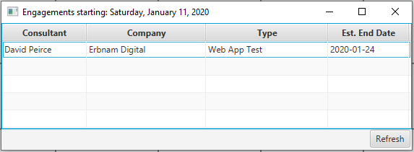

This added functionality allows the user to manually initiate a refresh to these views and observe SCATS data has been accurately stored and retrieved from the backend database.

**Re-Test**:

* Upon viewing an engagement scheduled to begin on Tuesday, January 28, 2020; concluding on February 10, 2020, a change to the engagement is made to shorten the estimated fieldwork duration from 2/10 to 2/5.

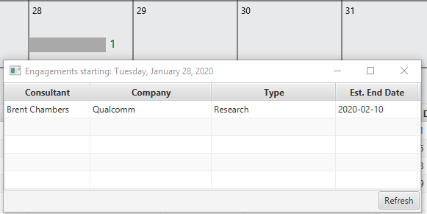

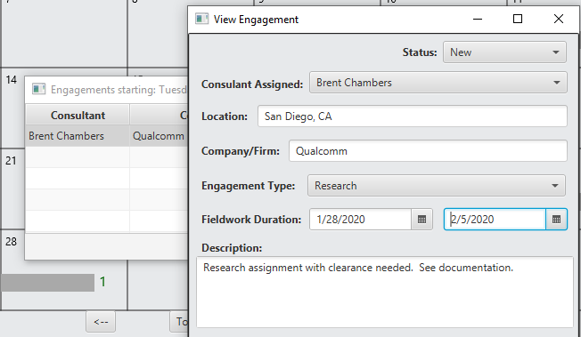

The change is made within the View Engagement tool by clicking SAVE and the Popup Engagements window that spawned the View Engagement tool is still reflecting the old date.

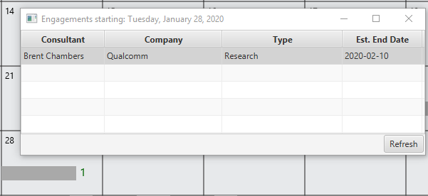

After clicking the newly implemented REFRESH button, the data is accurately updated to reflect the changes made to the Engagement.

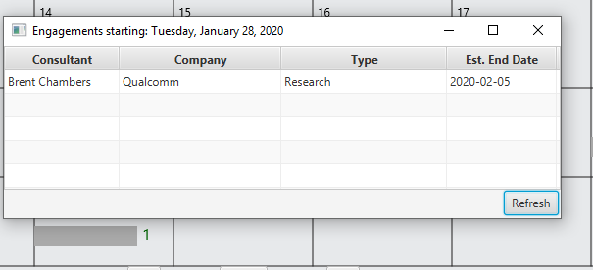

* Upon viewing the Engagement records within the SCATS backend database, it can be observed the Engagement tested has been accurately updated. Status: Fixed/Pass

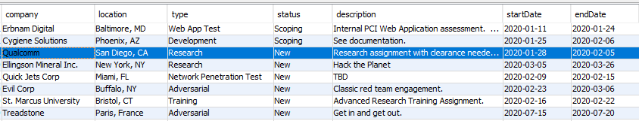

|  |  |  |
| --- | --- | --- |
| Test Case ID | Date Re-Tested | Pass/Fail |
| Case004 | 1/20/2020 | Pass |

## ViewConsultantController.java

|  |  |  |  |  |  |
| --- | --- | --- | --- | --- | --- |
| Test Case ID | Date Tested | Pass/Fail | Severity of Defect | Summary of Defect | Comments |
| Case011 | 1/19/2020 | FAIL | Medium | The system cannot find the image file because the filepath used within the function contains bad characters. | Fix is to implement relative path functionality to retrieve the file from the file system. |

**Code Analysis**: When an image file is selected from the View Consultants tool in efforts to provide a profile picture associated with a consultant, if the file path is complex and contains spaces or special characters, the system cannot load the image from the full path.

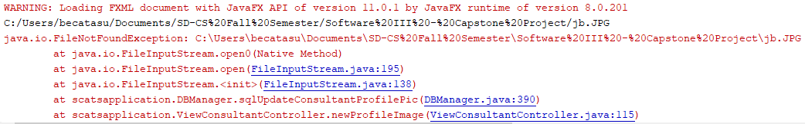

Expected behavior is to immediately upload the image file as a blob to the database upon selection. This functionality is effective when the filepath is simple and does not contain spaces or complex characters.

**Code Changes Made**: The Image path value within the newProfileImage() function of ViewConsultantController was changed from a toURI() value to a getAbsolutePath() value. This allowed the system to produce a local filepath that was not altered with encoded characters and could thus be found for image upload to the database.

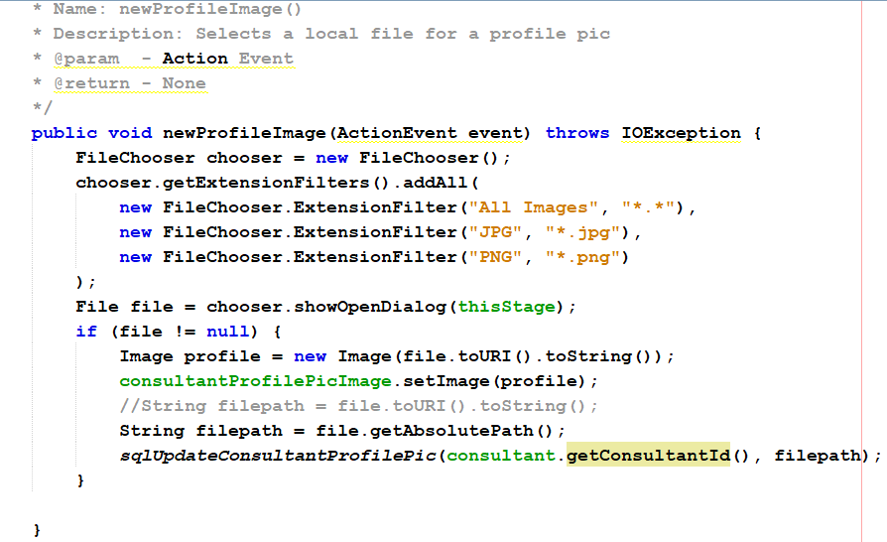

**Re-Test**:

The image for the consultant David Webb was effectively added as the consultant’s profile picture, and persisted through the closing and opening of the View Consultant tool.

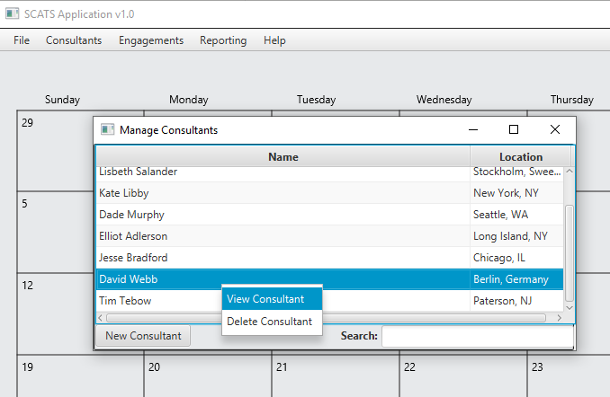

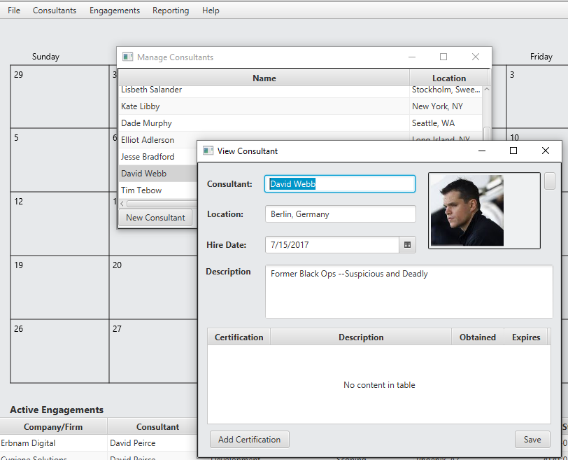

* Upon viewing the Consultant records within the SCATS backend database, it can be observed the Consultant profile image associated with Consultant David Webb has been correctly stored as a blob. Status: Fixed/Pass

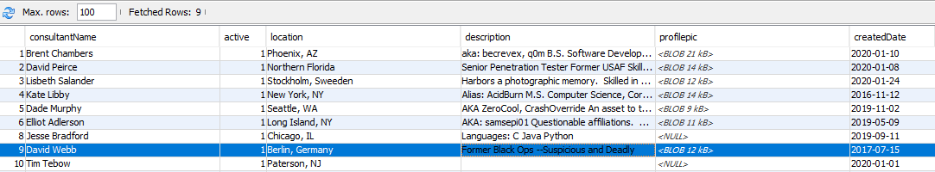

|  |  |  |
| --- | --- | --- |
| Test Case ID | Date Re-Tested | Pass/Fail |
| Case004 | 1/20/2020 | Pass |

# Unit Test Details (Passed Tests)

ManageSystemUsersController.java

|  |  |  |  |  |  |
| --- | --- | --- | --- | --- | --- |
| Test Case ID | Date Tested | Pass/Fail | Severity of Defect | Summary of Defect | Comments |
| Case005 | 1/19/2020 | Pass | None | None | None |

NewCertificationController.java

|  |  |  |  |  |  |
| --- | --- | --- | --- | --- | --- |
| Test Case ID | Date Tested | Pass/Fail | Severity of Defect | Summary of Defect | Comments |
| Case006 | 1/19/2020 | Pass | None | None | None |

NewConsultantController.java

|  |  |  |  |  |  |
| --- | --- | --- | --- | --- | --- |
| Test Case ID | Date Tested | Pass/Fail | Severity of Defect | Summary of Defect | Comments |
| Case007 | 1/19/2020 | Pass | None | None | None |

UpdateCertificationController.java

|  |  |  |  |  |  |
| --- | --- | --- | --- | --- | --- |
| Test Case ID | Date Tested | Pass/Fail | Severity of Defect | Summary of Defect | Comments |
| Case008 | 1/19/2020 | Pass | None | None | None |

EditSystemUserController.java

|  |  |  |  |  |  |
| --- | --- | --- | --- | --- | --- |
| Test Case ID | Date Tested | Pass/Fail | Severity of Defect | Summary of Defect | Comments |
| Case002 | 1/19/2020 | Pass | None | NA | NA |

EngagementOptionsController.java

|  |  |  |  |  |  |
| --- | --- | --- | --- | --- | --- |
| Test Case ID | Date Tested | Pass/Fail | Severity of Defect | Summary of Defect | Comments |
| Case003 | 1/19/2020 | Pass | None | NA | Main UI interface needs to be updated after Reactivate All is executed in Manage Engagements.  The Main UI could also benefit from a Search function and an engagement counter. |

NewEngagementController.java

|  |  |  |  |  |  |
| --- | --- | --- | --- | --- | --- |
| Test Case ID | Date Tested | Pass/Fail | Severity of Defect | Summary of Defect | Comments |
| Case010 | 1/19/2020 | Pass | None | None | None |